TASK 8:
class Solution {
public int firstUniqChar(String s) {
int[] count = new int[26];
for (int i = 0; i < s.length(); ++i)
++count[s.charAt(i) - 'a'];
for (int i = 0; i < s.length(); ++i)
if (count[s.charAt(i) - 'a'] == 1)
return i;
return -1;
}
}
Case 1:
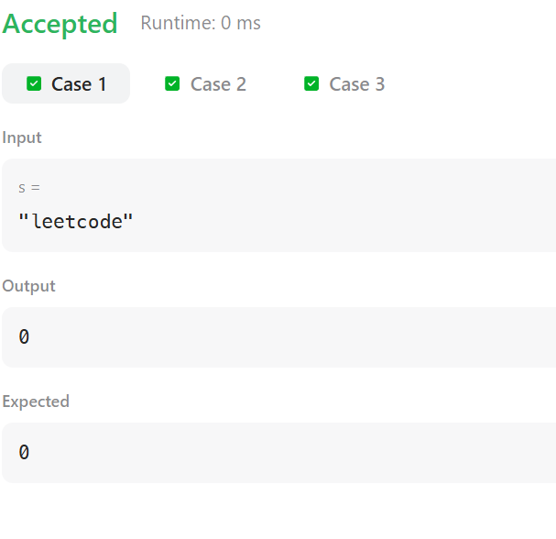
Case 2:
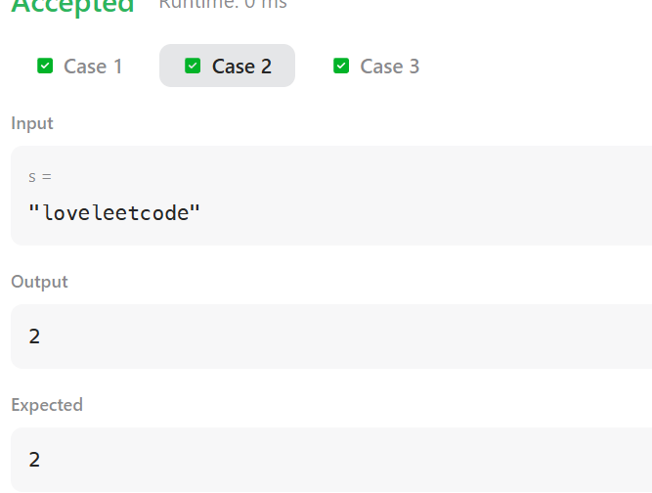
Case 3:
Accepted
Runtime: 0 ms
Case 1
Case 2
Case 3
Input
s =
"aabb"
Output
-1
Expected
-1

